**Hybrid Solar Thermal Heat Pump with stratified water storage tank Model**

**BY**

**CHIBUZOR FIDELIS NWOZUZU**

**MATRIC NO: PEE/P/17/18/0035**

**A PROJECT REPORT SUBMITTED TO THE DEPARTMENT OF ELECTRICAL/ELECTRONIC ENGINEERING,**

**COLLEGE OF ENGINEERING AND ENVIRONMENTAL STUDIES, OLABISI ONABANJO UNIVERSITY, IBOGUN CAMPUS, OGUN STATE**

**IN PARTIAL FULFILLMENT OF THE REQUIREMENTS FOR THE AWARD OF POST GRADUATE DIPLOMA (PGD) IN ELECTRICAL AND ELECTRONICS ENGINEERING**

**MAY, 2019**

# CHAPTER 1

## Introduction

## Background

Over the recent years, systems that combine solar thermal collector technology and heat pumps has been well marketed for both space heating and for domestic hot water production. The use of renewable energy has become the talk of the day. Excessive carbon dioxide CO2 emissions have raised the concern such that engineering firms had to work out on strategies to enhance the going-green mantra. Mapping out control strategy to minimize energy cost is nowadays popular topic in the Automation and Control industry.

The IEA SHC programme launched in 2010 Task 44: Solar and Heat Pump Systems, which was a joint effort with the IEA Heat Pump Programme under the Annex 38 set the vibrant platform for these systems IEA,2014. Over 6 years now international teams have been working together to contribute to better and improve the performance of S+HP systems. Non-renewable energy has been the backbone of industrialization from a long time ago. The substitution of non-renewable energy with renewable energy like solar energy has much profound advantages. These range from electricity saving, it is clean and also can be available all the year round. However due to different weather conditions and also the day and night times, solar thermal collector cannot do it alone. Hence the combination of the solar and heat pump systems. It is against this background, that this project seeks to better and optimize the reduction of the energy costs by designing a control strategy that minimizes the cost as much as possible. Figure 1 shows the schematic for the solar heat pump combination system. A detailed explanation of the schematic will be discussed in Chapter 3 of this report.

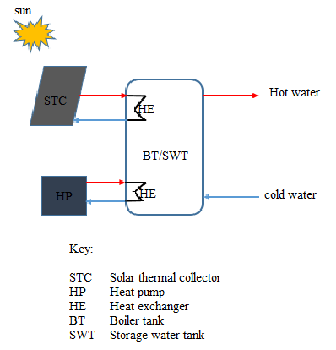

Figure 1: Schematic diagram for the system

## Problem definition

The problem is to compare the differences in the hot water storage tank between the boiler tank and the stratified tank. This is done by looking at day and night tariffs and weather conditions need to take into account.

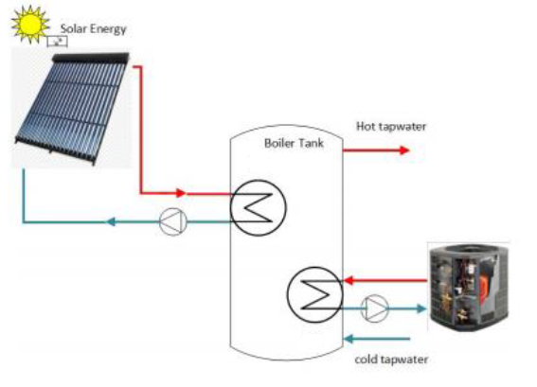

Figure 2: The current situation

Figure 2, shows the STC and the HP works on complementary bases. The STC works when there is sufficient solar energy. If the temperature drops below 40 degrees Celsius the heat pump takes over and starts to heat the water in the BT via the HE/s. Although the overall goal is to minimize the cost, Table 1 below summaries the definition in Figure 2.

Table 1 Summary of the System

|  |  |
| --- | --- |
| Goal for Control | 1) Hot tap water temperature = Desired temperature [K] |
| Process output with sensor  (with sensor(s)) | 1) Hot water temperature [K], [degrees Celsius]  (Sensor: measured with temperature sensor) |
| Control Input with actuator  (with actuators) | 1) Electric power to HP [W]  (actuator: heater)  2) Solar energy to STC [J]  (actuator: heater) |
| Major disturbances | 1) Ambient temperature [K] |

**1.3 Aim and Objective**

The aim of this project is to investigate the potential application of hybrid system for hot-water heating application in a smart home.

The objectives of this project are stated below:

To design an Optimal Control strategy to minimize the cost of energy for the Solar Heat Pump (S+HP) combination systems.

To realize the stated objective, the following specific objectives are considered:

1. To develop a simulation model for the hybrid system in

Simulink/MATLAB.

1. To develop optimal controller that will maximize energy usage and

Minimize electricity costs.

# CHAPTER 2

## Literature



## Introduction

The global energy demand rose by 2.1% in 2017 compared to 0.9 % in 2016 (Agency &Iea, 2015). It is estimated that about 72% of this rise is met by fossil fuels, a quarter by renewable and the others by nuclear. Furthermore, the sudden growth in energy demand has been attributed to the significant increase in population growth, urbanization, industrialization and technological advancement in energy-demanding applications. However, this has led to energy shortfall and the consequence is quite dominant in cold climate nations that predominantly rely on energy for thermal comfort and domestic use. In South Africa, for instance, access to electricity has significantly increased in the last two decades since the demand for electricity has escalated and the power utility has been unable to meet the energy demand. Consequently, this has led to an energy deficit, global blackout and load shedding, which has resulted to about 9.4% increase in electricity price annually (Kusakana, 2017; Wanjiru, Sichilalu, & Xia, 2017).

The largest oil producing country in Africa, Nigeria, predominantly generate energy through the fossil fuels, which is of low capacity due to pipeline vandalization, poor governance, non-implementation of energy policy and obsolete existing energy infrastructure and to boost energy capacity many households and businesses relying on fossil fuel to meet energy demand. Also, regions with the substantial requirement for heating and cooling often experience an increase in net annual energy demand and the existing infrastructures are at low capacity to meet such high demand. Subsequently, energy consumption of residential (A.A.Okubanjo & O.K. Oyetola, 2017) building forms a large percentage of global energy demand and domestic hot-water contributes about 42% of total energy consumption. However, this has posed a serious pressure on energy demand especially during the peak energy period. Hence, the reliance on fossil based fuel to generate the needed energy has not only posed a colossal threat to the world’s climate but also endangered the inhabitants by releasing an harmful toxic gases such as CO2, CCF, and methane etc. According to [6–8], energy consumption in the residential building contributed to about 25% of greenhouse emission. In response to the energy deficit and the associated environmental hazards, many developing nations are migrating to the renewable source (solar) source of energy technology that is clean, inexhaustible, and pollution-free in residential building so as to ensure net zero energy and as well minimizing the cost of electricity consumption annually. Hence, the most promising technologies are solar thermal collectors, photovoltaics and heat pumps as reported in Andreas et al. (Gschwend&Bertsch, 2012). Also, recent works have been reported by [8–14] on the integration of heat pump systems and photovoltaic/thermal (PV/T) system including solar thermal assisted heat pump systems. A combined solar thermal pump with seasonal energy storage for both space heating and domestic hot-water in cold climate region is proposed by (H. Li et al., 2014).The performance analysis for the proposed system and the conventional method revealed a significant energy saving and adaptability of the proposed system to perform efficiently in a cold region than the existing system. Further, Khakimova et al (Khakimova et al., 2015) developed an hybrid model predictive control strategy to minimize the cost of electricity through integration of renewable energy that generate both heat and electricity to meet the need of lingering energy demand. The economic and technical benefits of combined solar collector and geothermal heat pump system was investigated in the work of Mehrpooya et al,(Mehrpooya et al., 2015). A matlab/Simulink based model of a solar thermal and heat pump system is developed in (Chel& Kaushik, 2017; Esmaeil, Nezhad, &Hoseinzadeh, 2017). Recently, Dai et al. (Dai et al., 2017) presented a novelty hybrid photovoltaic solar assisted loop heat pipe and heat pump model. The model has advantage to switch between two modes and this allows the system to save energy usage during sunny day and also has the tendency to rely on loop heat pipe mode without significant power consumption. The author further suggested that a Heat loop mode is suitable for low solar radiation and ambient temperature in winter. A thermal storage tank is implemented in [20–23] to enhance domestic hot water. Andreas et al.(Genkinger, Dott, &Afjei, 2012) experimental and theoretical investigated domestic heating system integrated with solar thermal collector and heat pump in which ice-water tank serves as thermal storage system. Bai et al. (Bai, Chow, Ménézo, &Dupeyrat, 2012), investigated the potential application of the hybrid PV/T solar-assisted heat pump system for indoor sport Centre

water heating. The performance of the same hybrid system is further examined with evacuated tube integrated with phase change material. İt was found out that the phase change material has strong tendency to store energy effectively and also permit a delay cooling after sunset or late evening. A numerical and experimental study on the performance of a heat-pipe solar photovoltaic/thermal HPS PV/T heat pump system was investigated in the study of Chen et al. (Chen et al., 2017). The author further formulated a mathematical model based on a dynamic distributed parameter and quasi-steady state distributed parameter for HPS PV/T system and heat pump respectively. The capacity of heat pump and the number of HPS collectors are optimized to improve the system performance based on the mathematical model. A solar thermal heat pump hybrid system provides a viable solution to the energy imbalance by reducing electricity charges through optimizing the operation of the heat pump, integrating the available solar energy and by shifting electricity consumption to the low-cost night time tariffs. However, the solar radiation is relatively low and heat requirements are quite enormous in winter, hence, the solar thermal collector is combined with a heat pump to compensate for heat needed. Also, the heat pump can also benefit from the lower night-time electricity tariff when combined with a thermal storage.

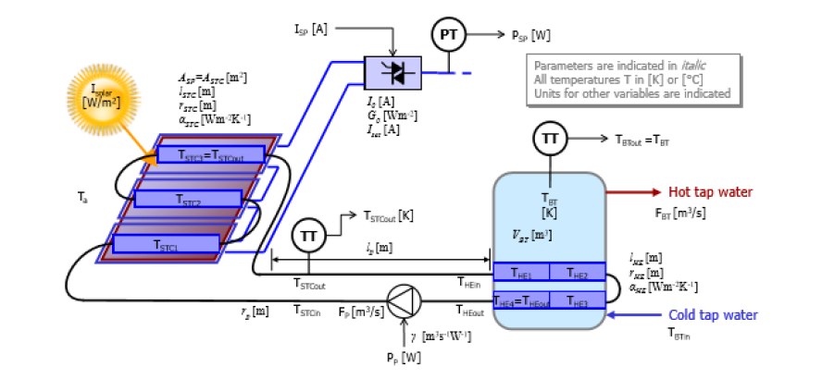

Figure 3: Schematic diagram of PVT integrated cooling system

In this case the hybrid PV-thermal system was modelled using a set of differential equations and to simulate dynamics accurately pipe sections were used for solar thermal collectors and heat exchanger. The sectioning is solved by the backward Euler method. This implies that the temperature $T(x+∆x)$ represents the temperature over section $(x+∆x)$ which provides a convenient order of calculations: from the input to the output of the pipe under consideration.

Taking cognisance of the fact that the pipe length between STC and HE/BT exceeds the pipe length in the STC and the HE, delays were incorporated into the system model.

Also the following assumptions have been made:

1. The Boiler Tank is a closed system, thus always filled with water, and perfectly mixed,

Thus $T_{BTout}=T_{BT}$

1. As a closed system that connects the STC with the HE, the flow rate $F_{p}\left[m^{3}/s\right]$ is considered proportional to the pump $P_{p}\left[W\right]$, and the fluid in the system is water.
2. The heat transfer resistance between SP and STC is negligible small compare to the heat transfer resistance between SP+STC combination and the ambient air.
3. The water is considered not compressible.

According to the conservation of energy, the energy balance equations for each component layer of photovoltaic- thermal system with water cooling can be written. Figure 3 gives the direction by which this project is projected towards. However this introduction modelling case 3 and 4 didn’t do much to look at the different temperatures which will be present in the BT or storage tank for domestic use. Therefore the scope of this project will encroach further to look into the stratification of the stored water. Another different issue worth noting is that, case 3 and case 4 in review speaks to the solar panels producing electricity, whereas our project speaks to the use of the thermal energy produced by the solar thermal collector to heat up the water in the boiler.

## System Definition

Solar heat pump combination is a hybrid system. Both the solar thermal collector and the heat pump systematically compensate each other. Although the water is mainly heated by the solar thermal collector, the two work according to the set conditions. The following is the set conditions;

* The heat pump only turns on when the water temperature in the storage tank drops below 40 degrees Celsius.
* A full water storage tank.

Figure 4 gives a precise white box model. To avoid ambiguous definition of the system, modeling language is mathematics in this report. For that go to chapter 3. So understanding S+HP system shown in Figure 2, as a process allows us to assign defined inputs, disturbances and get the desired outputs.

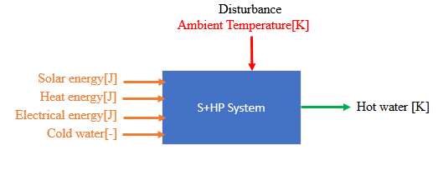

Figure 4 System definition as a box showing the system to be modelled

## System Inputs

The systems have inputs.

* Solar energy
* Heat from heat exchanger
* Electrical energy from the heat pump
* Cold water

## System Outputs

Outputs are key elements for the result realization. The main output for the S+HP system is;

* Domestic hot water temperature

The system outputs are relevant to check if the goals are met. The outputs also helps to know which sensor to use.

## Disturbances

Ambient temperature is the main disturbance of the system. Disturbances are natural key elements that cannot be ignored.

## Goal for Control

A model of the system is done in Chapter 3 of the report. Modeling the dynamics of the system is done in order to design a controller. It is necessary to have an unambiguous goal of the system. The main goal of the project is to provide domestic hot tap water. Therefore it can be listed as follows;

* Hot water temperature = desired temperature [K]
* STC water flow = desired flow [m3s]
* HP water flow = desired flow [m3s]

# CHAPTER 3

## Modeling

The schematic diagram in Figure 1 and Figure 2 shows an overview of the the solar heat pump combination system. The water is mainly heated by the solar thermal collector. The heat pump only turns on when the water temperature drops below 40 degrees celcius. The solar heat pump combination system in Figure 2 contains 6 main sub models. These are solar thermal collector, heat pump system, heat exchanger, piping, boiler tank and/ storage water tank. In order to simulate the dynamics sufficiently accurate, pipe sections are used for both the STC and the HE. The solar heat pump combination system was modelled using a set of differential equations and to simulate dynamics accurately pipe sections were used for the solar thermal collector (STC) and the heat exchanger (HE). Just like in the hybrid- thermal system mentioned earlier in the literature review, to solve sectioning backward Euler method is used. This means that the temperature $T(x+∆x)$ represents the temperature over section $(x+∆x)$ which provides a convenient order of calculations: from input to output of the pipe under consideration. For the reason that the pipe length between STC and HE/BT exceeds the pipe length in the STC and the HE, delays were incorporated into the model.

Critical assumptions have been made:

1. The Boiler Tank is a closed system, thus always filled with water.
2. The water is perfectly mixed, that means $T_{BTout}[K]=T_{BT}[K]$.
3. The ambient temperature (disturbance) Ta = Toutside = 273 [K].
4. As a closed system that connects the STC with the HE, the flow rate $F_{p}\left[m^{3}/s\right]$ is considered proportional to the pump $P_{p}\left[W\right]$, and the fluid in this system is water.
$$F_{p}\left[m^{3}/s\right]∝P_{p}\left[W\right]$$

5. The water is considered not compressible.

**Data Flow Diagram (DFD) for the system**

The Data Flow Diagram serves as outline of the solar heat pump combination system given in figure 2.

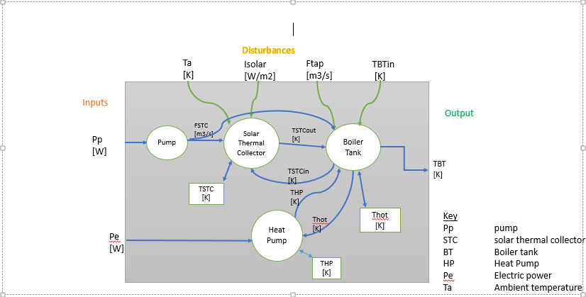

Figure 5: Data Flow Diagram for the system

**Simulator**

The simulator for the system was built in Simulink, based on the differential equations given in sections 3.1 to 3.6, with the parameter values of Table 7. The simulator was used to make the analysis for the system.

Important notes

* The initial conditions for all integrators are 273+20 [K]. This avoids long runs to reach steady state situations for the system.
* To simulate delays for the system, variable transport delay blocks are used. The maximum delay is put on 1600 [s] and initial buffer length on 256*1024.

The section 3.1 to 3.6 gives a detailed description (set of differential equations) of the all the sub models for the whole system. [5]. the model of the system was be derived from these sets differential equations.



## Solar Thermal Collector (STC)

Metals conduct heat much better than air, the active surface area is considered to distributed evenly over all sections and contributing evenly to all sections. The back of the STC is ideally isolated. Therefore the area exchanging heat to the outside air equals the active area for radiation ASTC.

As earlier mentioned at the beginning of this chapter. All the sub models shall be mathematically described. The STC is defined by the following three differential equations.

Energy Balance for the STC

$$\frac{dQ}{dt}=\left(P_{in}-P_{out}\right)+P_{solar}-P_{loss} (3.1.1)$$

Remark; Pin  is the power provided by the STC.

Pout is the output power from the STC.

Psolar is the power from the sun.

Ploss is the power loss in the STC.

Based on the choice for backwards Euler: we have the following expression to define the STC as a unit.

$$c_{p}ρπ_{STC}^{2}Δx\frac{{dT}_{STC}(x+Δx}{dt}=c_{p}ρ_{p}\left[T_{STC}\left(x,t\right)-T_{STC}x+\left(x+Δx,t\right)\right]+{-α}_{STC}\frac{Δx}{l_{STC}}A_{STC}\left[T_{STC}\left(x+Δx,t\right)-T_{outside}\right]+\frac{Δx}{l_{STC}}A_{STC}l_{Solar}\left(t\right) 3.1.2)$$

Consider the STC to be segmented; the temperature of the solar thermal collector per section will be defined by the following TSTC1…TSTCoutin equations (3.1.3)….up to (3.1.6).

$$\frac{d}{dt}T_{STC1}=\left(-d_{1}F_{p}-d_{2}\right)T_{STC1}+d_{1}F_{p}T_{STCin}+d_{2}T_{outside}+d_{3}I_{Solar} (3.1.3)$$

$$\frac{d}{dt}T_{STC2}=\left(-d_{1}F_{p}-d_{2}\right)T_{STC2}+d_{1}F_{p}T_{STC1}+d_{2}T_{outside}+d_{3}I_{Solar} (3.1.4)$$

$$\frac{d}{dt}T_{STC3}=\left(-d_{1}F_{p}-d_{2}\right)T_{STC3}+d_{1}F_{p}T_{STC2}+d_{2}T_{outside}+d_{3}I_{Solar} (3.1.5)$$

$$\frac{d}{dt}T_{STCout}=\left(-d_{1}F_{p}-d_{2}\right)T_{STCout}+d_{1}F_{p}T_{STC3}+d_{2}T_{outside}+d_{3}I_{Solar} (3.1.6)$$

with;

$$d_{1}=\frac{1}{πr_{STC}^{2}Δx},$$

$$d_{2}=α_{STC}\frac{A_{STC}}{c_{p}ρπ_{STC}^{2}I_{STC}},$$

$$d_{3}=\frac{A_{STC}}{c_{p}ρπ_{STC}^{2}I_{STC}}$$

i

Table 2: Model variables and parameter values for the STC

|  |  |  |  |
| --- | --- | --- | --- |
| Abbreviation | Description | Value | Units |
| $$c_{p}$$ | Specific heat capacity of water | 4180 | J/(KgK) |
| $$ρ$$ | Density of water | 1000 | Kg/m3 |
|  | Active area solar thermal collector | 2.2 | m3 |
|  | Heat transfer solar thermal collector | 8 | W/(m2K) |
|  | Length solar thermal collector tube | 3 | m |
| $$r_{STC}^{2}$$ | Radius solar thermal collector | 6.10-3 | m |
|  | Length solar thermal collector section | $$l_{STC}/6$$ | m |

The equations 3.1.3 to 3.1.6 will mathematically define the STC for the system.

## Heat Exchanger (HE)

Heat exchangers are devices used to transfer heat between two or more fluid streams at different temperatures. [6] Heat exchangers are used for different things among them power generation, electronics cooling, chemical processing, refrigeration and automotive applications. In this section we use the heat exchanger to transfer heat energy from either the solar thermal collector or the heat pump. The heat exchanger will be essential for heating up the water in the boiler tank.

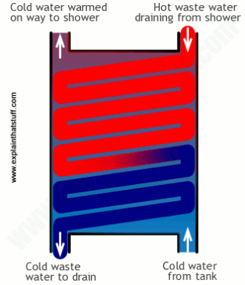Saving energy is a big and costly task for both industry and at home. Heat exchangers are widely used for different purposes for examples in cars, ships and planes. But for the purpose of our thesis we are closely looking to it for heating up water to have domestic hot water. In this thesis the shell and tube heat exchanger is used in Figure 6. This type of heat exchanger is sufficient to heat up the water. We don’t need the plate/fin for this task.

Figure 6: Heat exchanger diagram

Figure 7 Heat exchanger diagram

How the heat exchanger works?

Heat exchanger allows heat from the fluid (dirty water in the heat exchanger) to pass to a second (water in the boiler tank) without the two fluids necessarily mixing. Simply put heat exchanger transfers heat between fluids without transferring the fluid that carries the heat.

Therefore in our case the two heat exchangers differently coupled to either the solar thermal collector and the other attached to the heat pump will alternatively work as already explained earlier. See figure 1 and/2 the schematic diagram.

Just like with the STC we have the Energy Balance in the HE;

$$\frac{dQ}{dt}=\left(P_{in}-P_{out}\right)-P_{loss} (3.2.1)$$

Where;

$P_{in}$ is the power from the heat exchanger.

$P_{out}$ the output power from the heat exchanger.

$P_{loss}$ the loss from the heat exchanger.

Based on the backwards Euler:

$$c_{p}ρπ_{HE}^{2}Δx\frac{{dT}_{HE}(x+Δx}{dt}=c_{p}ρ\left[T_{HE}\left(x,t\right)-T_{HE}\left(x+Δx,t\right)\right]{-α}_{HE}2πr_{HE}Δx\left[T_{HE}\left(x+Δx,t\right)-T_{hot}\right] (3.2.1)$$

Take note per section ($T_{HEout}=T_{HE4}$)

$$\frac{dT_{HE1}}{dt}=\left(-c_{1}F_{p}-c_{2}\right)T_{HE1}+c_{1}F_{p}T_{HEin}+c_{2}T_{hot} (3.2.2)$$

$$\frac{dT_{HE2}}{dt}=\left(-c_{1}F_{p}-c_{2}\right)T_{HE2}+c_{1}F_{p}T_{HE1}+c_{2}T_{hot} (3.2.3)$$

$$\frac{dT_{HE3}}{dt}=\left(-c_{1}F_{p}-c_{2}\right)T_{HE3}+c_{1}F_{p}T_{HE2}+c_{2}T_{hot} (3.2.4)$$

$$\frac{dT_{HEout}}{dt}=\left(-c_{1}F_{p}-c_{2}\right)T_{HEout}+c_{1}F_{p}T_{HE3}+c_{2}T_{hot} (3.2.5)$$

With, $d_{1}=\frac{1}{πr^{2}∆x}, c_{2}=\frac{2α_{HE}}{c_{p}ρr_{HE}}$

Table 3: Model variables and parameter values for the HE.

|  |  |  |  |
| --- | --- | --- | --- |
| Abbreviation | Description | Value | Units |
| $$r_{HE}$$ | Radius for heat exchanger | 6.10-3 | m |
|  | Total heat transfer rate heat exchanger | 2000 | W/(m2K) |
|  | Length heat exchanger tube section | $$l_{HE}/4$$ | m |
| $$l_{HE}$$ | Length heat exchanger tube | 2 | m |

Remark;

Parameters not indicated in the table such as THE ,, and $ρ$ are assumed known to the reader and are visible in the equations above. Alternatively the reader can see Table 7 in the appendix.

## Heat Pump (HP)

The air-to-water heat pump will be used for heating up the water inside the boiler tank by diverting heat from the outside air (source) at a lower temperature to a higher temperature. The model consists of a mass flow/temperature with a dynamic Coefficient of Performance (COP). The COP value depends on the external air temperature and the condenser out flow temperature. The heat capacities of air and water are different. For this reason, the mass flow on the evaporative side will be much higher to provide enough energy for the water heating.

The simplified model description is given below:

Coefficient of Performance (COP):

$${COP}_{c}=\frac{T_{c,out}+273}{T_{c,out}-T_{e,out}}$$

$$COP=η_{c}*{COP}_{c}$$

Heat Flow;

$$q_{c}=COP*E_{wp} [W]$$

$$q_{e}=q_{c}-E_{wp}=(COP-1)*E_{wp} [W]$$

Out Flow Temperatures;

$${C*\frac{{dT}_{c,out}}{dt}=ṁ_{c}*c_{w}*\left(T_{c,in}-T_{c,out}\right)+q}_{c} [W]$$

$${C*\frac{{dT}_{e,out}}{dt}=ṁ_{e}*c_{air}*\left(T_{e,in}-T_{e,out}\right)+q}_{e} [W]$$

For parameter description see the table below, note also that the values will be used in the simulations.

Table 4: Model variables and parameter values for the HP.

|  |  |  |  |
| --- | --- | --- | --- |
| Abbreviation | Description | Value | Units |
| $$c_{air}$$ | Heat capacity of air | 1000 | J/KgK |
| $$ṁ_{e}$$ | Mass flow evaporator | 0.05 | Kg/s |
| $$ṁ_{c}$$ | Mass flow condenser | 0.05 | Kg/s |
| C | tank capacity | 100000 | J/K |
| $$E_{wp}$$ | Input electricity | 4000 | W |

## Boiler Tank (BT)

The BT will adhere to the below listed assumptions.

Assumptions:

1) The boiler tank should be smaller than the storage water tank.

2) Homogeneous conditions in the boiler tank.

3) The boiler tank is ideally mixed and ideally isolated.

The BT will adhere to the following differential equations.

Energy Balance;

$$\frac{dQ}{dt}=P_{HPHE}+P_{HE} (3.4.1)$$

Where;

$\frac{dQ}{dt}$ The rate at which the energy is converted in the BT.

$P_{HPHE}$ Power from both heat pump and heat exchangers.

$P_{HE}$ Power from heat exchanger.

The following relationship will hold for the entire boiler tank

$$c_{p}ρV_{BT}=$$

$$α_{HE}2πr_{HE}Δx\left(T_{1}-T_{hot}\right)+α_{HPHE}2πr_{HPHE}Δx\left(T_{HP1}-T_{hot}\right)$$

$$α_{HE}2πr_{HE}Δx\left(T_{2}-T_{hot}\right)+α_{HPHE}2πr_{HPHE}Δx\left(T_{HP2}-T_{hot}\right)$$

$$α_{HE}2πr_{HE}Δx\left(T_{3}-T_{hot}\right)+α_{HPHE}2πr_{HPHE}Δx\left(T_{HP3}-T_{hot}\right)$$

$$α_{HE}2πr_{HE}Δx\left(T_{4}-T_{hot}\right)+α_{HPHE}2πr_{HPHE}Δx\left(T_{HP4}-T_{hot}\right)$$

$$=α_{HE}2πr_{HE}Δx\left(T_{1}+T_{2}+T_{3}+T_{4}-{4T}_{hot}\right)$$

$$+α_{HPHE}2πr_{HPHE}Δx\left(T_{HP1}+T_{HP2}+T_{HP3}+T_{HP4}-4T_{hot}\right) (3.4.2)$$

Table 5: Model variables and parameter values for the BT.

|  |  |  |  |
| --- | --- | --- | --- |
| Abbreviation | Description | Value | Units |
| $$V_{BT}$$ | Volume of the boiler tank | 0.08 | m3 |
|  |  |  |  |

To avoid repetition some parameters are already described in tables above. See table 7 in the appendix.

## Piping and pump power

The pipe lengths $l_{p}$ between STC and BT are significant. Their length also exceeds the pipe length in the STC and the BT. Therefore the connecting piping, delays should be included. But as these connecting pipes are thermally well isolated, heat losses can be neglected.

The flow through the system is related to the pump power as:

$$F_{p}=RP_{p}$$

The transport delays are included as;

$$T_{BTin(t)}=T_{STCout}(t-∆t)$$

$$T_{STCin(t)}=T_{BTout}(t-∆t)$$

$$T_{HPBTin(t)}=T_{Cout}(t-∆t)$$

$$T_{Cin(t)}=T_{HPBTout}(t-∆t)$$

Note these equations are not considered differential equations but direct relations. Relations between TBTout ;TSTCin;TSTCout and TBTin

With;

$$∆t=\frac{πr_{p}^{2}l_{p}}{F_{p}}$$

**Note**, this represent the transport time between BT and STC or BT and Heat Pump as a one-way journey.

The power $P_{STC}$ provided by the solar thermal collector to the boiler tank is given in the following expression $:$

$$P_{STC}=C_{p}ρF_{p}(T_{HEin}-T_{HEout})$$

Table 6: Model variables and parameter values for the Pump and piping.

|  |  |  |  |
| --- | --- | --- | --- |
| Abbreviation | Description | Value | Units |
| $$F_{pmax}$$ | Water flow in the piping | 1.10-5 | m3/s |
|  | Distance between solar thermal collector and boiler tank | -- | m |
| $$R$$ | Flow-power ratio pump | Fpmax/Ppmax | m3/J |
| Ppmax | Maximum pump power | 20 | W |

## Storage Water tank (SWT)

The stratified hot water storage tank in the system acts as a buffer to store hot water obtained from the solar thermal collector and the heat pump respectively. Depending on the amount of solar energy available during the day, the SWT can be heated with hot water to store more energy from the sun and used when there is no more sunlight and when the user demand exists.

Y6654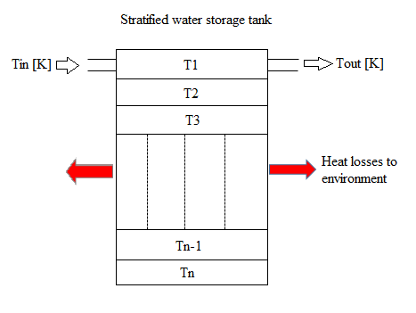

Figure 8: Stratified storage water tank scheme

Yes the temperature distribution in a water storage tank is typically 3 dimensional. But for the purposes of this project, it is enough to approximate the system to be one dimensional with variable temperature along the height of the tank. This is because the heat losses in a day are really low in comparison night time. As shown in Figure 7 the water in the tank has different level of temperature as it flows from the inlet to the outlet. For the purposes of this work only 4 layers has been considered.

The energy balance of the SWT in layer nodes can be written as stated by the equation 3.6.1

Energy balance in layer node;

$$\frac{dQ}{dt}=P_{HPHE}+P_{HE}+P_{layerbottotop}-P_{cold}-P_{loss} (3.6.1)$$

As mentioned above the storage tank have been segmented into 4 different interconnect layers for easy simulation.

Water stratification equations in the storage water tank are sated as below;

$$c_{p}ρ\frac{V_{BT}}{4}\frac{{dT}_{hot}}{dt}=P_{HE}-\left(T_{hot}-T_{2}\right)\left(\frac{KA}{x}-mfc_{p}\right)-P_{loss} (3.6.2)$$

$$c_{p}ρ\frac{V_{BT}}{4}\frac{{dT}_{2}}{dt}=\left(T_{hot}-T_{2}\right)\left(\frac{KA}{x}\right)-\left(T_{2}-T_{3}\right)\left(\frac{KA}{x}-mfc_{p}\right)-P_{loss} (3.6.3)$$

$$c_{p}ρ\frac{V_{BT}}{4}\frac{{dT}_{3}}{dt}=\left(T_{2}-T_{3}\right)\left(\frac{KA}{x}\right)-\left(T_{3}-T_{4}\right)\left(\frac{KA}{x}-mfc_{p}\right)-P_{loss} (3.6.4)$$

$$c_{p}ρ\frac{V_{BT}}{4}\frac{{dT}_{4}}{dt}=P_{HPHE}+(T_{3}-T_{4})\left(\frac{KA}{x}+mfc_{p}\right)-F_{p}{c_{p}ρ\left(T_{4}-T_{cold}\right)-P}_{loss} (3.6.5)$$

# CHAPTER 4



## Simulation Analysis

.

Differences scenarios are used look at appendix for more information. An ex- ample with simulation runs simulation in 10 hours. After 5 hours, there is no sun anymore. After 6 hours, tap water is used for 30 minutes at a flow of 6[l/m].In figure 2 the green line shows hot water temperature on the top level of stratifying tank, the red line show bottom level of stratifying tank and the blue line show water temperature on the mixed tank. In the stratify tank, There are temperature differences when the sun is shining. After the sun when down the water in the stratify tank starts to mix. When tap water was open the bottom water temperature starts to drop immediately while the top water temperature drop much slower and after half an hour’s they start to mix again. In the mixed tank, there is no difference between the temperature from top and bottom of the tank.

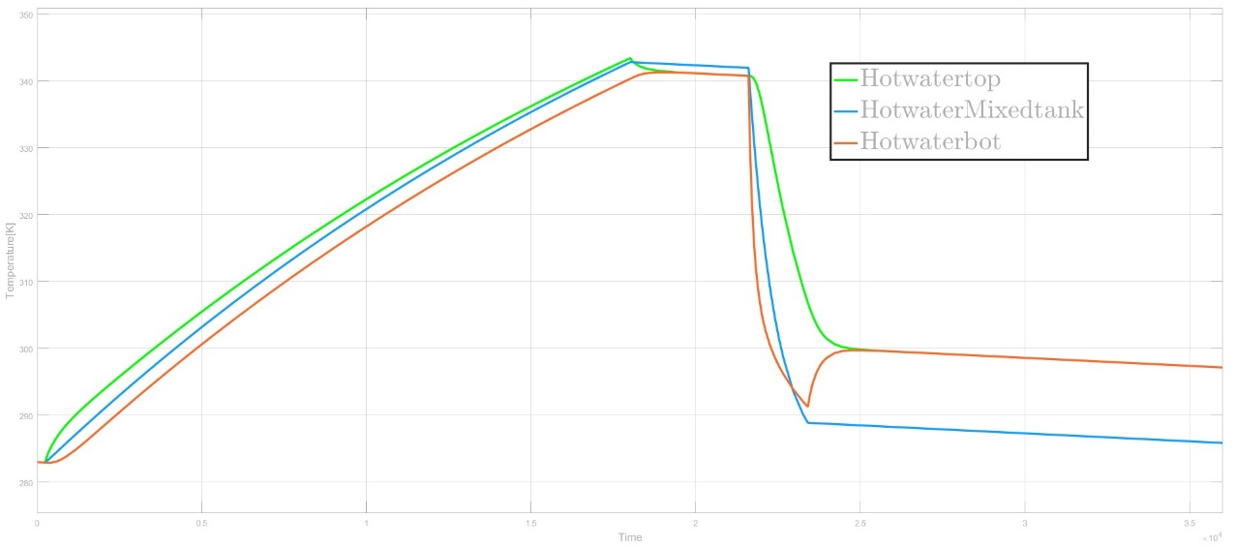

Figure 2: Solar Heat pump.

In the stratification tank, the water temperature has been divided into 4 nodes (4 layers). In figure 3 the differences temperature between each node are shown.

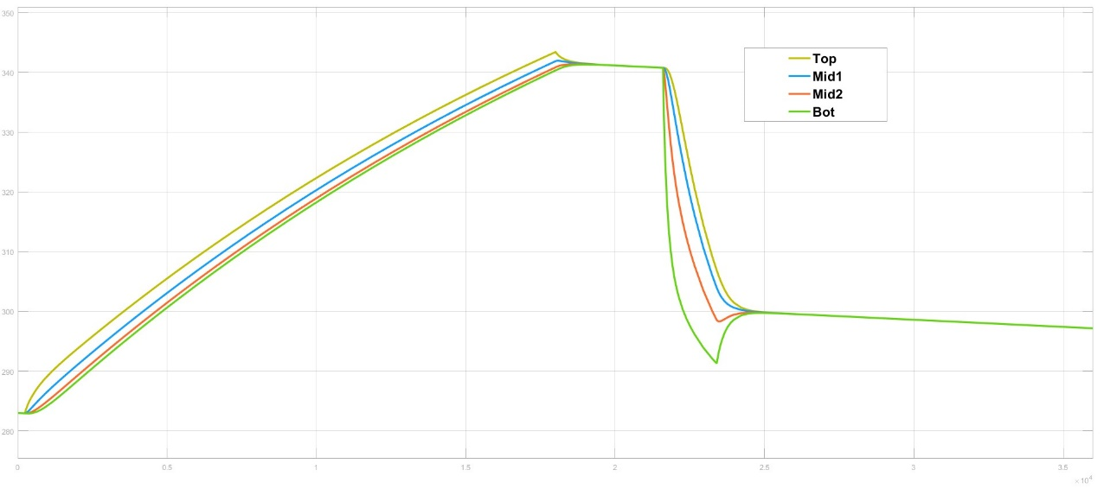

Figure 3: Water Stratify result.

**3.1 Simulation results with Heat Pump On**

The same simulation has run again with heat pump added to the water storage tank. In figure 4 Heat pump on when water temperature drop below 323[K] or40 $℃$ and turn off when water temperature above 343[K] or 60 $℃$.

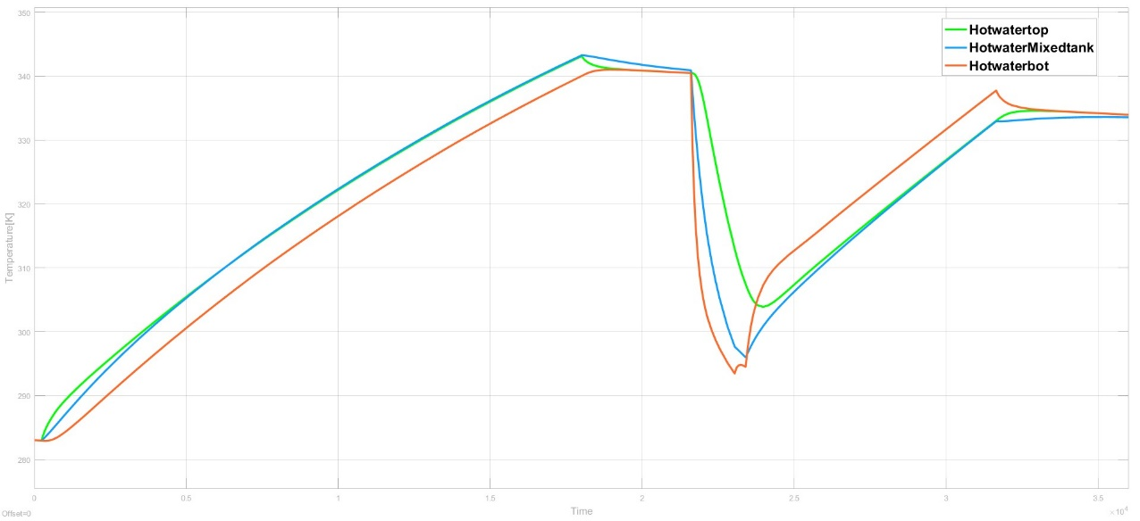

Figure 4: Heat Pump on.



# CHAPTER 5



## Conclusions



In this project, a model of solar-thermal heat pump heat hybrid system was presented to investigate the potential application of hybrid system for hot-water heating application in a smart home. An improved ODE models have been established for modelling a wide sort of heating system with Backward -Euler method for pipe sectioning. A simulation model was developed with the aids of Simulink and MATLAB scripts to analyse thermal performance. Four solar panels with thermal collectors were connected in series for maximum power transfer. Consequently, waste heat energy were harvested and converted into useful energy by inlet flow of tap water through heat exchanger connected to the back of the solar thermal collector which continuously cooled the solar panels. The study revealed that the hybrid system can satisfy the energy demand provided that the solar thermal collector is sufficiently within the acceptable value needed for domestic hot water. In case of low solar radiation level at night, the temperature drops below the acceptable value, in this case, 40 degree Celsius, hence the heat pump is turned on to compensate for the heat needed on demand for domestic hot-water heating at a reduce electricity consumption. The result further revealed that combined solar thermal and heat pump system has tendency to save energy if optimally utilized and mitigate the climate crisis. The aforementioned findings revealed that the developed hybrid model can be integrated in sub-African regions to effectively boost energy supply and as well promote zero emission in building envelopes. The superfluous heat energy harvested can be used for other domestic purposes which will indubitably reduce the demand of electricity for heating purposes.

Table 7: Input Parameters for the simulation the whole model

|  |  |  |  |
| --- | --- | --- | --- |
| Abbreviation | Description | Value | Units |
| cp | Specific heat capacity of water | 4180 | J/(KgK) |
| ρ | Water density (rho) | 1000 | $${Kg/m}^{3}$$ |
| VBT | Volume Boiler Tank | 0.08 | $$m^{3}$$ |
| $$α_{HE}$$ | Total heat transfer rate Heat Exchanger | 2000 | $${W/(m}^{2}K)$$ |
| $$r_{HE}$$ | Radius Heat Exchanger tube section | $$6*{10}^{-3}$$ | m |
| $$l_{HE}$$ | Length Heat Exchanger tube | 2 | m |
| $${Δx}_{HE}$$ | Length Heat Exchanger tube section | $$l_{HE}/4$$ | m |
| $$A_{STC}$$ | Active Solar Thermal Collector | 2.2 | $$m^{2}$$ |
| $$α_{STC}$$ | Total heat transfer rate Solar Thermal Collector | 8 | $${W/(m}^{2}K)$$ |
| $$r_{STC}$$ | Radius Solar Thermal Collector tube | $$6*{10}^{-3}$$ | m |
| $$l_{STC}$$ | Length Solar Thermal Collector tube | 3 | m |
| $${Δx}_{STC}$$ | Length Solar Thermal Collector tube section | STC/4 | m |
| $$P_{Pmax}$$ | Maximum Pump power | 20 | W |
| $$F_{Pmax}$$ | Maximum flow at maximum Pump power | $$1*{10}^{-5}$$ | $$m^{3}/s$$ |
| R | Flow-power ratio to Pump | $$FP_{Pmax}/PP_{Pmax}$$ | $$m^{3}/J$$ |
| $$r_{p}$$ | Radius pipe between Solar Thermal Collector and Boiler Tank | $$6*{10}^{-3}$$ | m |
| $$l_{p}$$ | Distance between Solar Thermal Collector and Boiler Tank | 10 | m |
| $$C_{airx}$$ | Heat capacity of Air | 1000 | $$[J/KgK]$$ |
| η | Efficiency air/water heat pump | 0.4 | [-] |
| ṁe | Mass flow evaporator | 0.05 | Kg/s |
| ṁc | Mass flow condensor | 0.05 | Kg/s |
| C | Capacity | 100000 | [J/K] |
| Ewp | Electricity in | 4000 | W |
| $$P_{loss}$$ | Power loss by outside temperature | 80 | W |
| k | Heat transfer between layers | 0.58 | W/mK |
|  | Acreage of transfer layer | 0.4 | $$m^{2}$$ |
| mf | Mass flow between layer | 0.1 | Kg/s |
|  | Length of each layer of the storage tank | 0.2 | m |

# ACRONYMS

STC Solar Thermal Collector

BT Boiler Tank

HP Heat Pump

HE Heat Exchanger

S+HP Solar Heat Pump Combination Systems

DFD Data Flow Diagram

COP Coefficient of Performance

IEA International Energy Agency

WST Water Storage Tank

HW Hot Water

CW Cold Water

SISO Single Input Single Output system

MIMO Multiple Inputs Multiple Outputs system

MISO Multiple Inputs Single Output system

MPC Model Predictive Control

# REFERENCES

Assessments_WhyAndHow_200515, *E. Tazelaar*

Solar and Heat Pump Systems Position Paper, Task44/Annex38 *International Energy Agency IEA, 30 September 2014*

Solar heat pump systems for heat applications, Analysis of the sytem performance and possible solution for improving system performance. *Stefano Poppi Doctorial Thesis 2017 SE- 100 44 Stockholm, Sweden*

Sheets_IntroModeling_2014_week2.pdf, *E. Tazelaar 2014*

OptimalcontrolforSolarHeatPumpsystems.pdf, *Trun Nguyen, October 2017*

www.engr.mun.ca/-Yuri/Courses/MechanicalSystems/HeatExchangers.pdf

<https://docs.lib.purdue.edu/cgi/viewcontent.cgi?article=1148&context=ihpbc>

Modelling, Simulation and predictive control of the medium temperature Solar Cooling Plant *Thesis by NirajRathod*, Matricola 834168. Academic year 2015-2016

A.A.Okubanjo, & O.K.Oyetola. (2017). Modeling and Simulation of Hybrid PV- Thermal (PVT) Systems for Energy Efficiency in Nigeria. *Amity Journal of Engineering and Technology Journal of Engineering and Technology*, *2*(1), 7–15. Retrieved from http://amityuniversity.ae/prospective-students/AJET-3.pdf

Agency, I. E., & Iea, T. (2015). *Energy Efficiency Outlook for South Africa – Sizing up the opportunity*.

Aisa, A., & Iqbal, T. (2016). Modelling and simulation of a solar water heating system with thermal storage. *2016 IEEE 7th Annual Information Technology, Electronics and Mobile Communication Conference (IEMCON)*, 1–9. https://doi.org/10.1109/IEMCON.2016.7746283

Bai, Y., Chow, T. T., Ménézo, C., & Dupeyrat, P. (2012). Analysis of a hybrid PV/thermal solar-assisted heat pump system for sports center water heating application. *International Journal of Photoenergy*, *2012*. https://doi.org/10.1155/2012/265838

Chel, A., & Kaushik, G. (2017). Renewable energy technologies for sustainable development of energy efficient building. *Alexandria Engineering Journal*. https://doi.org/10.1016/j.aej.2017.02.027

Chen, H., Zhang, L., Jie, P., Xiong, Y., Xu, P., & Zhai, H. (2017). Performance study of heat-pipe solar photovoltaic/thermal heat pump system. *Applied Energy*, *190*, 960–980. https://doi.org/10.1016/j.apenergy.2016.12.145

Cheng, C., Peng, J., Liao, W., & Chang, C. (2016). Relationship between building hot water usage and energy and carbon reduction. *Building Services Engineering Research and Technology*, *37*(6), 682–693. https://doi.org/10.1177/0143624416644483

Dai, N., Xu, X., Li, S., & Zhang, Z. (2017). Simulation of Hybrid Photovoltaic Solar Assisted Loop Heat Pipe/Heat Pump System. *Applied Sciences*, *7*(2), 197. https://doi.org/10.3390/app7020197

Dipasquale, C., Bellini, A., & Fedrizzi, R. (2016). Model-based Design of a Solar Driven Hybrid System for Space Heating and DHW Preparation of a Multifamily House. *Energy Procedia*, *91*, 432–441. https://doi.org/10.1016/j.egypro.2016.06.165

Esmaeil, M., Nezhad, Y., & Hoseinzadeh, S. (2017). Mathematical modelling and simulation of a solar water heater for an aviculture unit using MATLAB/SIMULINK. *Journal of Renewable and Sustainable Energy*, *9*(November). https://doi.org/10.1063/1.5010828

Fiorentini, M., Cooper, P., & Robinson, D. A. (2015). Hybrid model predictive control of a residential HVAC system with PVT energy generation and PCM thermal storage.

Genkinger, A., Dott, R., & Afjei, T. (2012). Combining heat pumps with solar energy for domestic hot water production. *Energy Procedia*, *30*, 101–105. https://doi.org/10.1016/j.egypro.2012.11.013

Gschwend, A., & Bertsch, S. S. (2012). Domestic Heat Pump System With Solar Thermal Collectors as Heat Source and Annual Ice Storage.

Hoseinzadeh, S., & Azadi, R. (2017). Simulation and optimization of a solar-assisted heating and cooling system for a house in Northern of Iran. *Journal of Renewable and Sustainable Energy*, *9*(4). https://doi.org/10.1063/1.5000288

Khakimova, A., Shamshimova, A., Sharipova, D., Kusatayeva, A., Ten, V., Bemporad, A., … Rubagotti, M. (2015). Hybrid model predictive control for optimal energy management of a smart house. *Environment and Electrical Engineering (EEEIC), IEEE 15th International Conference On*, 513–518. https://doi.org/10.1109/EEEIC.2015.7165215

Kusakana, K. (2017). A survey of domestic water heating technologies, (July).

Lerch, W., Heinz, A., & Heimrath, R. (2014). Evaluation of combined solar thermal heat pump systems using dynamic system simulations. *Energy Procedia*, *48*, 598–607. https://doi.org/10.1016/j.egypro.2014.02.070

Li, H., Sun, L., & Zhang, Y. et. al. (2014). Performance investigation of a combined solar thermal heat pump heating system. *Applied Thermal Engineering*, *71*(1), 460–468. https://doi.org/10.1016/j.applthermaleng.2014.07.012

Li, S., Zhang, Y., Zhang, K., Li, X., Li, Y., & Zhang, X. (2014). Study on performance of storage tanks in solar water heater system in charge and discharge progress. *Energy Procedia*, *48*, 384–393. https://doi.org/10.1016/j.egypro.2014.02.045

Mehrpooya, M., Hemmatabady, H., & Ahmadi, M. H. et. al. (2015). Optimization of performance of Combined Solar Collector-Geothermal Heat Pump Systems to supply thermal load needed for heating greenhouses. *Energy Conversion and Management*, *97*, 382–392. https://doi.org/10.1016/j.enconman.2015.03.073

Padovan, R., Manzan, M., De Zorzi, E. Z., Gullì, G., & Frazzica, A. (2015). Model development and validation for a tank in tank water thermal storage for domestic application. *Energy Procedia*, *81*, 74–81. https://doi.org/10.1016/j.egypro.2015.12.061

R, J., D, P., S, S., & L, K. (2018). Analysis and optimisation of an insulated water tank for the domestic purpose. *Australian Journal of Mechanical Engineering*, *4846*, 1–10. https://doi.org/10.1080/14484846.2018.1461732

Rahman, A., Smith, A. D., & Fumo, N. (2016). Performance modeling and parametric study of a stratified water thermal storage tank. *Applied Thermal Engineering*. https://doi.org/10.1016/j.applthermaleng.2016.01.163

Rahman, H. A., Nor, K. M., Hassan, M. Y., Thanakodi, S., Majid, M. S., Hussin, F., … Malaysia. (n.d.). ModelingandSimulationofGridConnected PhotovoltaicSystemforMalaysianClimate UsingMatlab/Simulink.

Riffat, S. B., & Cuce, E. (2011). A review on hybrid photovoltaic/thermal collectors and systems. *International Journal of Low-Carbon Technologies*, *6*(3), 212–241. https://doi.org/10.1093/ijlct/ctr016

Sami, S. (2018). Modeling and Simulation of a Novel Combined Solar Photovoltaic-Thermal Panel and Heat Pump Hybrid System. *Clean Technologies*, *1*(1), 89–113. https://doi.org/10.3390/cleantechnol1010007

Shan, F., Cao, L., & Fang, G. (2013). Dynamic performances modeling of a photovoltaic–thermal collector with water heating in buildings. *Energy and Buildings*, *66*, 485–494. https://doi.org/10.1016/j.enbuild.2013.07.067

Sichilalu, S., Mathaba, T., & Xia, X. (2017). Optimal control of a wind–PV-hybrid powered heat pump water heater. *Applied Energy*, *185*, 1173–1184. https://doi.org/10.1016/j.apenergy.2015.10.072

Trabelsi, A., Belarbi, R., Abahri, K., & Qin, M. (2012). Assessment of temperature gradient effects on moisture transfer through thermogradient coefficient. *Building Simulation*, *5*(2), 107–115. https://doi.org/10.1007/s12273-012-0063-x

Wanjiru, E. M., Sichilalu, S. M., & Xia, X. (2017). Model predictive control of heat pump water heater-instantaneous shower powered with integrated renewable-grid energy systems. *Applied Energy*. https://doi.org/10.1016/j.apenergy.2017.05.033